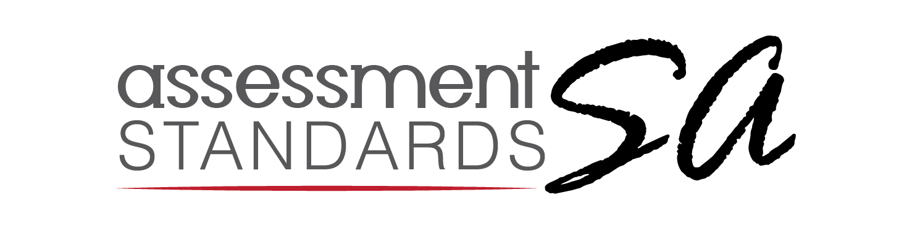

Terms and Conditions

Please read the Terms and Conditions relating to the test review process and sign to indicate your agreement to the terms. No consideration of test materials will be made without a signed terms and conditions statement.

I understand that:
- As a general rule, materials will be submitted electronically for review. Materials that are only available in printed or physical form will be dealt with on a case-by-case basis. These may incur additional costs for courier and may take longer to review. The test materials will be returned to the Applicant at the end of the review process, at the test submitter’s cost.
- Applicants have the right to determine whether certain test materials are commercially sensitive. Test reviewers will sign non-disclosure agreements for every test reviewed.
- The pool of reviewers for ASSA will be made public. However, the identity of the test reviewers involved in the review of a test will remain confidential up to the point of a published editorial panel test review. Within reason, and with motivation, Applicants may ask for specific individuals from the ASSA pool of reviewers not to be used.
- Any contact from a publisher in relation to test review must be directed via the administrator at ASSA.
- The test review fee is non-refundable once the test has been sent to reviewers. No materials may be submitted with an application once the review is underway.
- Only tests that meet the minimum standards will be published on list of certified tests on the ASSA website.
- Upon award of an ASSA Test Certificate of compliance with minimum standards, the test Applicants can affix to the test in paper or electronic form a notice that the instrument has been certified as of acceptable psychometric quality, and can use the ASSA registered test logo, as a ‘quality mark’.
- A full copy of the wording on a Certificate of Test Certification must be accessible to test takers, either in print on the test booklet or as an on-screen page for a computer-based or online test. The Test Certificate and the associated ASSA certified test logo shall relate only to the test which has been certified, and only to the language version covered in the submission to ASSA. It shall not be deemed to be an endorsement of the author, publisher or distributor, or any other test and may not be used in that way.
- A test can be certified for a ten-year period and is subject to a re-registration process thereafter. Once the review reaches the 10-year mark, the test will need to be submitted for a full review again. The full review process should be followed in this case. After 10 years, the test will be removed from the list of certified tests on the ASSA website and the use of the logo by the publisher must be suspended. The test review will also be removed from the ASSA website. The ten-year registration period is calculated from the original date of expiry.
- Tests which have undergone substantive changes which are inside a ten-year test certification cycle are eligible to be considered for an updated editorial panel review. Should the Editor consider that the substantive changes are such that a full test review is required, the Applicant will be advised of this, and the full test review fee will be applicable.
- A test submitted into the review and certification process may also be used for training reviewers on the ASSA review process.

- I confirm that I have obtained the consent of the copyright holder to submit the test into the ASSA test review and certification process.
- I confirm that I have read and understand the terms and conditions.

For attention by ASSA board:
- Applicants have the right to withdraw a test review from publication. In this case, no certificate will be issued, and the review will not be published. Applicants will not be reimbursed for the test review fee.
- Need to create “registered test”/”ASSA certified” logo; develop statement/text for certified tests

